Anderson Family on Mission
September 2018 edition
“The King will reply, ‘Truly I tell you, whatever you did for one of the least of these brothers and sisters of mine, you did for me.’"
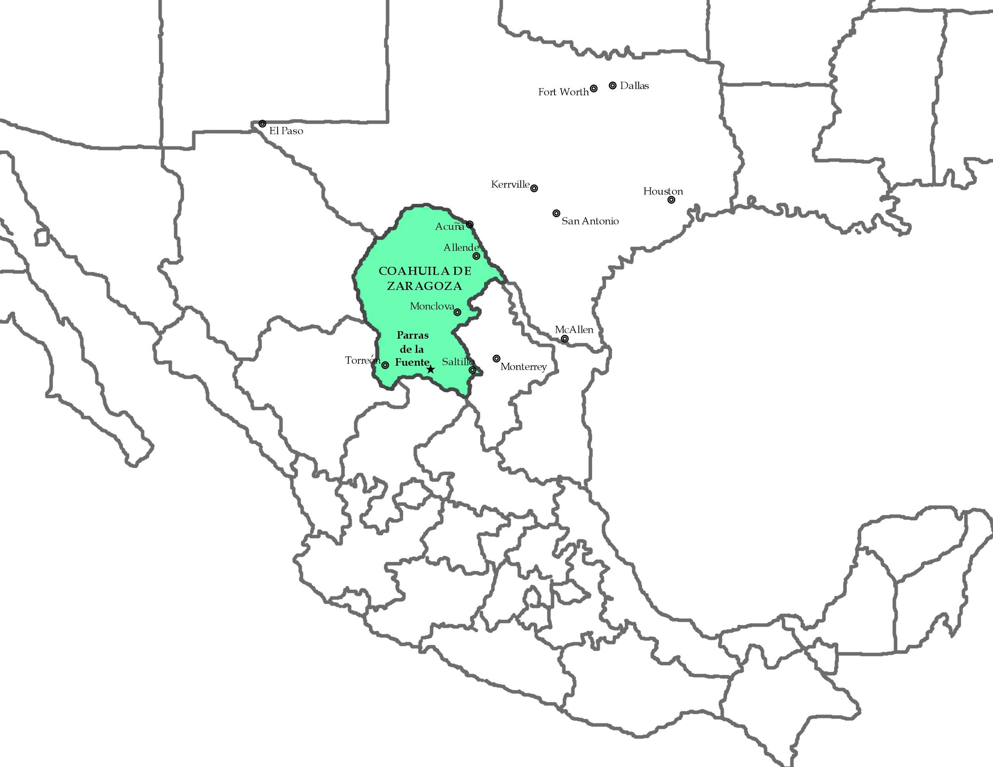
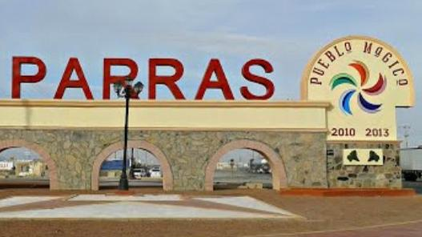
A tall sentry plant beckons us onward as it stands proud. Flitting across the road is a roadrunner. Through village after tiny village we draw ever closer to our dream. A giant Pueblo Magico sign in the midst of a roundabout marks our last major turn and, bouncing southward, we begin to see the telltale vineyards. Next, we see the pecan groves and a hillside sign welcoming us to town. Entering the town of Parras de la Fuente, where we will be ministering to impoverished children at the Vida Nueva Children’s Home, has been on my heart since March of 2010, when I first laid eyes on it.

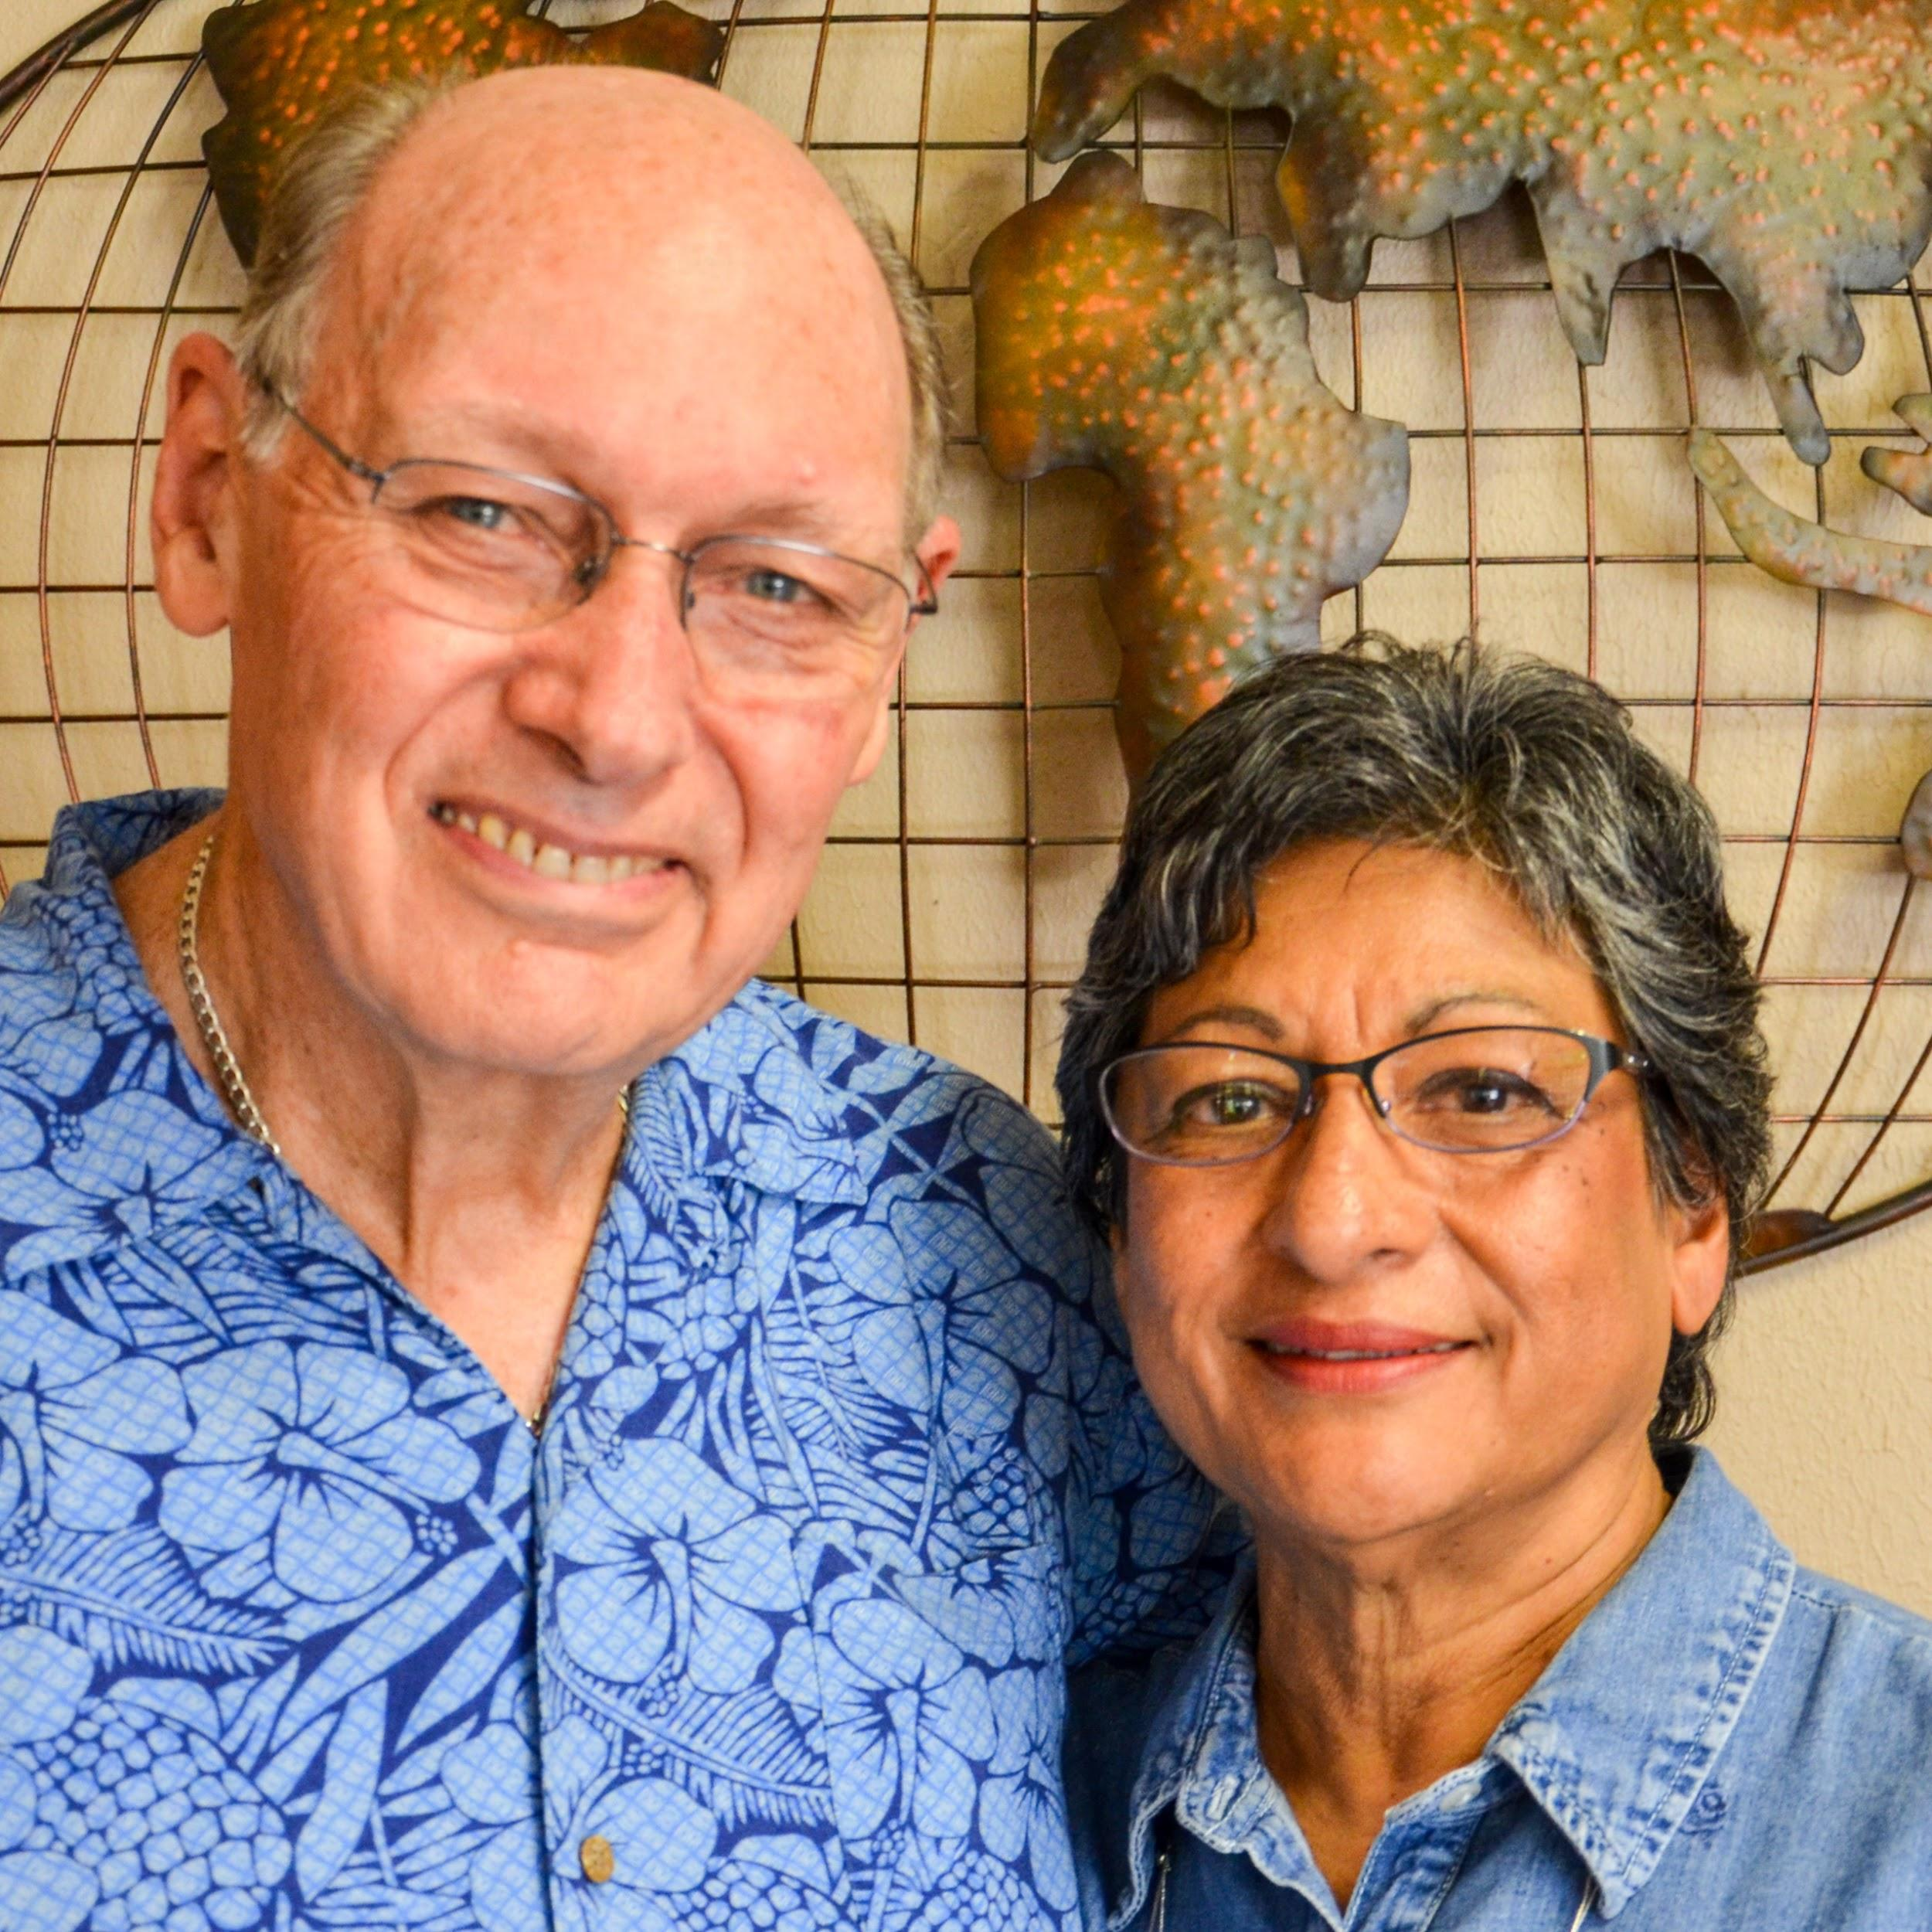
The Journey
Rewind to August 15th. We packed the last few things into our truck, said our final goodbyes, climbed aboard. Final destination: Parras de la Fuente, Coahuila, México. Along the way we stopped in Kerrville, TX, home of the US headquarters to Commission to Every Nation. Our Pastoral Care couple within CTEN, Dick and Birdie Johnson hosted us for a wonderful afternoon through breakfast the next morning. While we were there we visited the The Coming King Sculpture Prayer Garden. Our Lord has blessed our socks off by the Johnsons. They are faithful to pray, talk, advise, and listen as we change our whole way of life to follow God’s call.
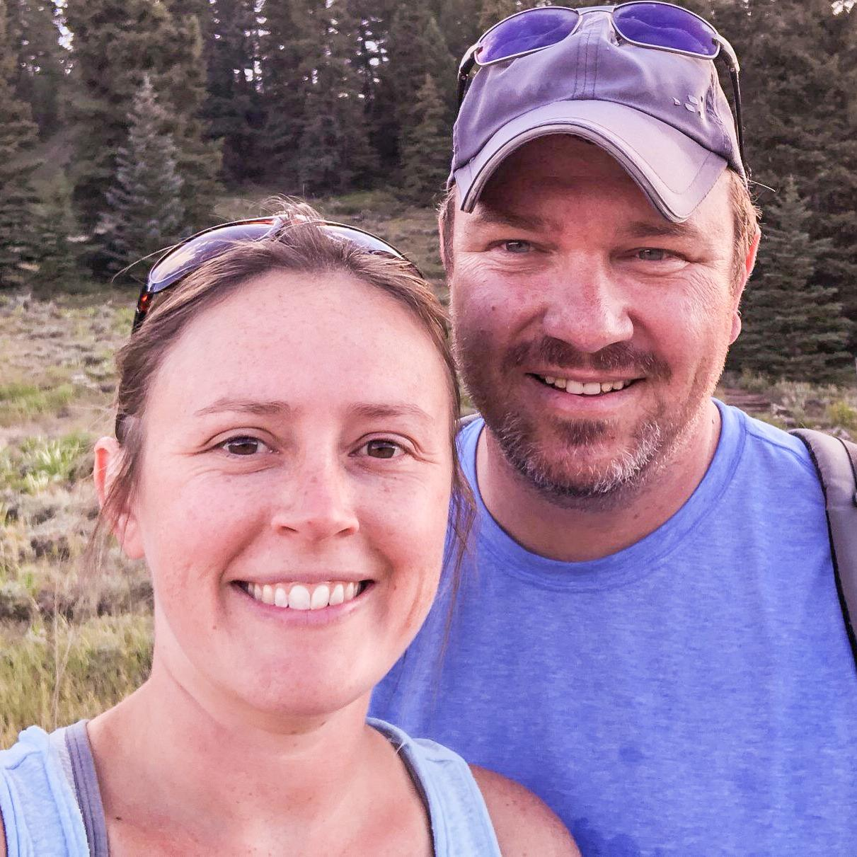
Into McAllen, TX, we rolled on the 17th, still stuffed to the gills in our Pathfinder. Chloe said, “The things falled on me and you put them up and they falled again. But I feeled great!” Reality was, we were ready to be done with that cramped transport. Overnight in McAllen, we visited with the couple that gave this opportunity to begin our journey to full-time ministry at Vida Nueva, Chad and Alise Mason. Along with Alise’s dad, Roger, they have guided us and given us loads of pertinent advice. Our backs are watched and prayed over by these amazing couples.
When we packed up Saturday the 18th, we headed south to the border. It was a relatively cool day and we hit the border southbound before eleven. We crossed the border and said, “Goodbye, US,” and “Hola, Mexico!” At the entry checkpoint, there is a point where border guards have the chance and every right to inspect anything and everything in our vehicle. I have had my vehicle inspected many times and was anxious about having to unload our vehicle’s interior, topper, and luggage rack. What a nightmare that would have been... When we arrived at that point in the complex, we received the red light, which means we were randomly selected to be inspected. The guard asked for our passports and to roll down the window behind me. I laughed lightly and asked if he minded holding things in as I rolled it down. He looked closer, laughed as he walked around to look in the other windows that wouldn’t cause an avalanche, and waved us through without another word. RELIEF isn’t a big enough word to encapsulate the massive emotion that filled our hearts as we passed through customs. It filled my brain, too! It was so filled that it replaced the thought of stopping to get our vehicle permit and visas! About 20 miles into Mexico, I regained my mental faculties and remembered in horror the consequences of that mistake. After calling my people, we drove back to the border crossing complex and ironed everything out with nary a guard rankled.
Since we’d left later than planned from McAllen, doubled back to the border, and waited for a fresh 7-11 Pizza along a toll road, we didn’t get in to the children’s home until about 5:30pm. After our little whoopsidaisy at the border and aside from a crazy driver passing someone passing a semi on a steep mountain pass, the rest of the drive (my tenth trip into Mexico!) was rather mundane. There was much talking, singing, and silence as we finished our trip. God was there with us and His providence is evident through all we’ve encountered. What a mighty God we serve!

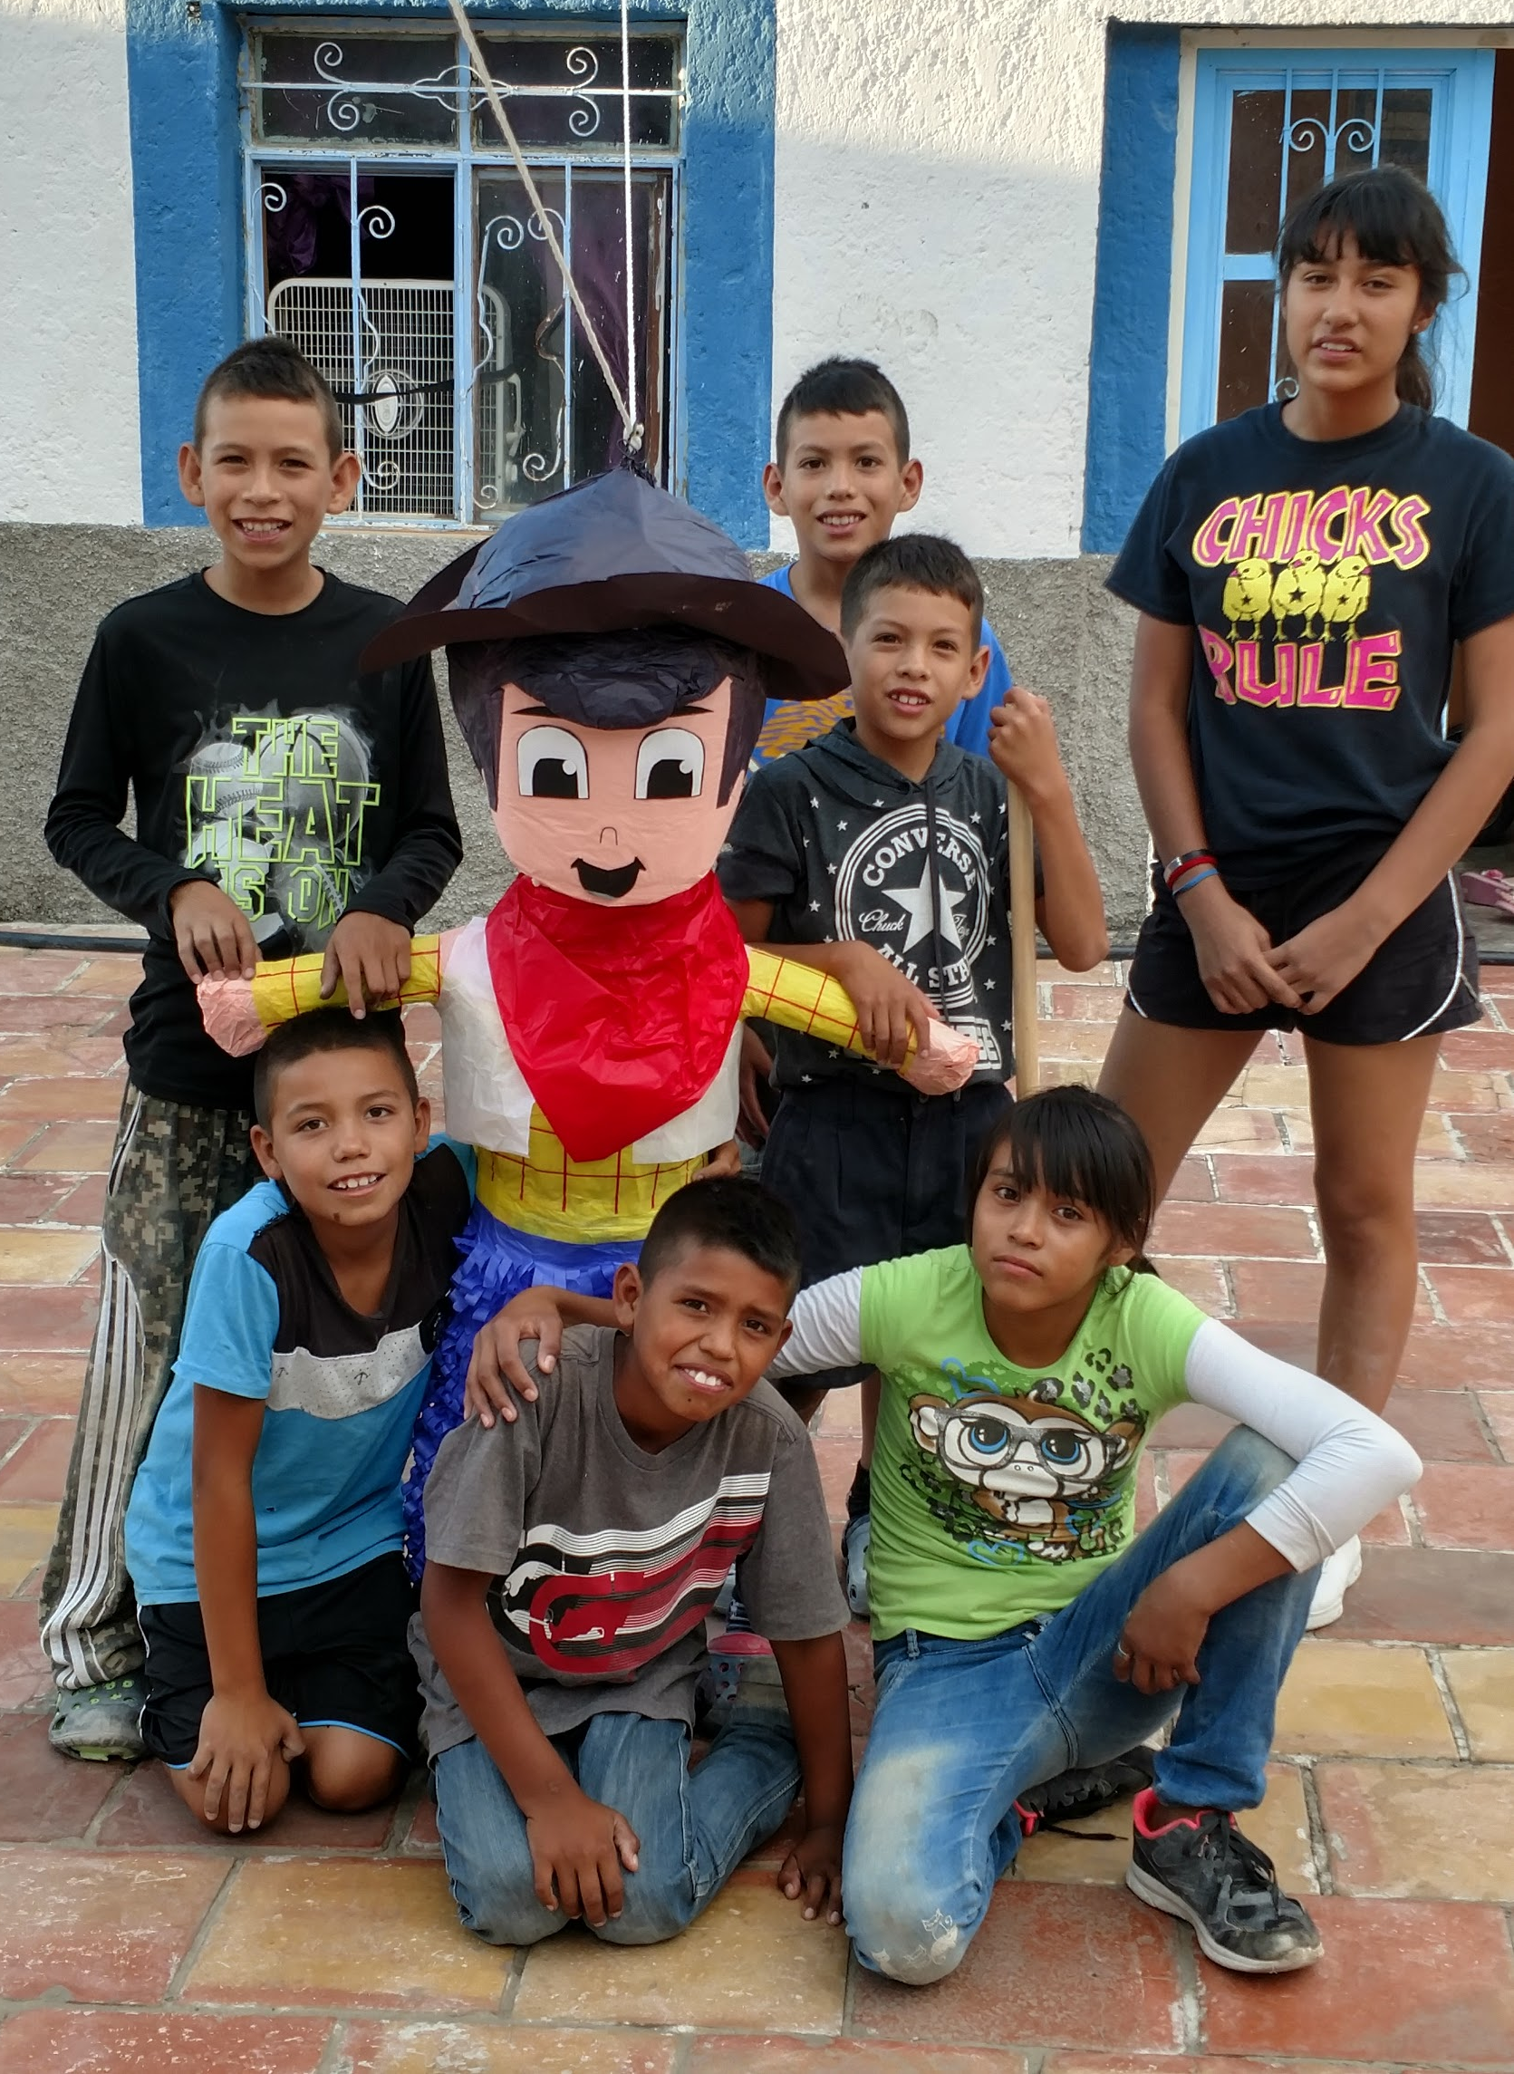
We have arrived!
Hannah and I have been blessed with the opportunity to serve the Lord Jesus at Vida Nueva, Nueva Esperanza (VN) children's home in Parras de la Fuente, México. We are, in effect, Dorm Parents for the children living in the home, concentrating our care on their spiritual and emotional health. At this time of the first draft of this letter, the children numbered seven, ranging in age from 8-13 years, but our hopes were realized when another boy was added! We pray to add more in the future. An orphanage this is not, rather it is a home where severely impoverished children live Sunday evening through Friday evening in order to attend school, and they return to what family they have over the weekends and summer break. The children to whom VN ministers are too poor to receive an education without the assistance of VN. The children receive their meals, school costs (tuition, books, uniforms, etc.), a safe place to live, and most importantly they are exposed to the Gospel.
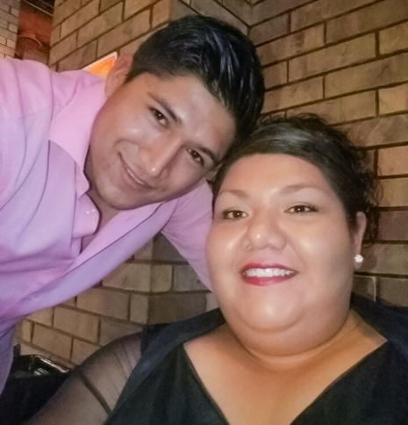
God has done marvelous things through the loving hands at VN and those hands have changed, as of April 2018. There is a new director since the former has married, moved to Monterrey, and just delivered her baby in July! We will be working closely with the new Director, Glenda, to care for the children. Both she and her husband are locals who were raised in the home and are good examples of success from VN. Having a national Director is a very important piece of the ministry, since they take care of government relations and know the customs and culture of the children. We maintain a supporting role and facilitate communications between the home and the Board.
In addition to caring for these wonderful kiddos, most of whom we had the privilege of meeting in March, we'll also be working with a national missionary church planter, Candelario. After our annual mission trip in March, we had the opportunity to receive some grassroots (organic/national/disciple-style) church planting training through No Place Left. Chad Mason (missions and mobilization pastor) of Calvary Baptist Church in McAllen, TX, led the training and also happens to be on the board of VN. Candelario is in Parras working in the same model, and we'll be growing into a role coordinating between new church plants, discipling/training leaders, and providing moral support as needed. We will be striving to raise Mexican disciplers who raise Mexican disciplers to the umpteenth generation; disciplers who meet together to worship, study the Word, and admonish one another in faith. This has been on my heart since 2010, when I first visited Parras and the children's home. Each year I return, God gives me a clearer view of how to reach these wonderful people living in darkness.
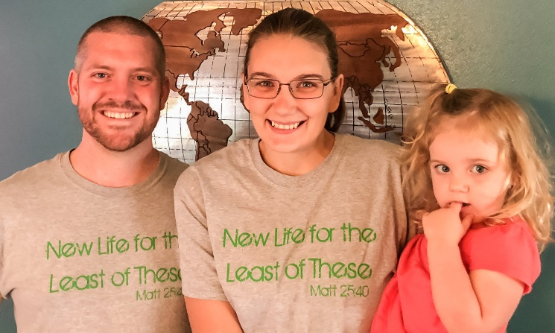
Some of you have been on this journey, teaching us since we were mere babes, others have been watching and praying from afar, and still others have just recently joined us as friends and supporters. Each of you is an integral part of this ministry in the lives of these sweet children to whom we are ministering here at Vida Nueva, Nueva Esperanza. Thank you for every moment you spend praying for us! Thank you for every moment you work as unto the Lord so that you can send us to live out our calling! Thank you for your leadership, kindness, and discipleship! We truly cannot say “Thank You” enough.
May God richly bless and fill you with courage to reach out to those around you with the Gospel. There is no other purpose for those who have been called by His name.
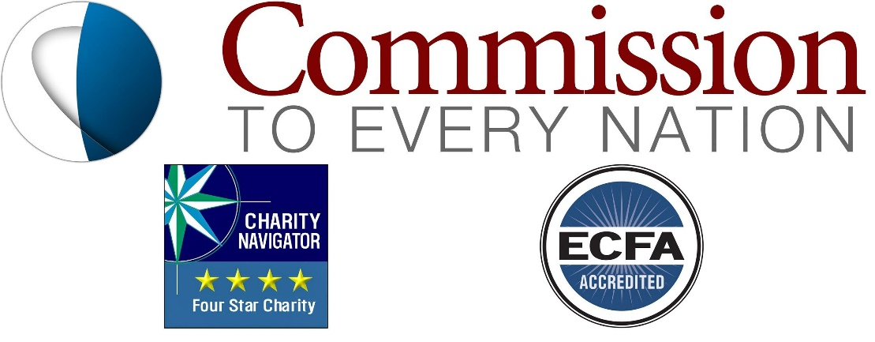
Please subscribe to our family blog for more! www.iEmissaries.org

